**Experiment 3**

**Student Name: Arushi Butola UID: 22BET10027**

**Branch: BE-IT Section/Group: 22BET_IOT_702/B**

**Semester: 6th Date of Performance: 31-02-25 Subject Name: Advanced Programming Lab-2 Subject Code: 22ITP-351**

1. **Aim:**

* Remove duplicates from a sorted list
* Medium Delete middle node of a list
* Remove duplicates from sorted lists 2
* Detect a cycle in a linked list
* Reverse linked list
* Rotate a list
* Sort List

**2.Objectives:**

* Implement functions to remove duplicate nodes from a sorted linked list, keeping only distinct elements.
* Implement a function to merge two sorted linked lists into a single sorted linked list.
* Ensure the resulting linked lists are sorted after modifications.
* Use linked list traversal techniques to efficiently process nodes.

1. **Problem :**Given the head of a sorted linked list, *delete all duplicates such that each element appears only once*. Return *the linked list sorted as well*.

# Algorithm:

* 1. **Initialize** a pointer current and set it to head.
  2. **Traverse** the linked list while current and current->next exist:
     + If current->val == current->next->val:
       - Store the duplicate node in a temporary pointer temp.
       - Update current->next to current->next->next (skipping the duplicate node).
       - Delete temp to free memory.
     + Else, move current to current->next (proceed to the next distinct node).
  3. **Return** the modified head pointer after processing.

# Code:

class Solution { public:

ListNode* deleteDuplicates(ListNode* head) { ListNode* current = head;

while (current && current->next) {

if (current->val == current->next->val) {

ListNode* temp = current->next; current-

>next = current->next->next; delete temp;

} else {

current = current->next;

}

}

return head;

}

# Output:

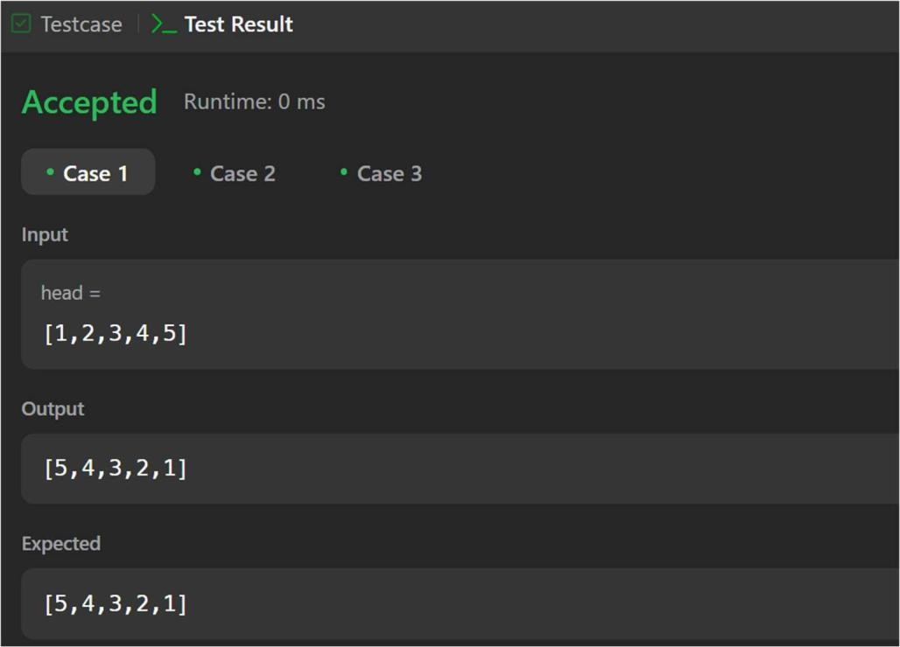

1. **Problem :** You are given the head of a linked list. Delete the middle node, and return *the* head *of the modified linked list*.

# Algorithm:

## Handle edge case:

* + If head == nullptr (empty list) or head->next == nullptr (only one node), return nullptr because the middle node is the only node.

## Use the slow and fast pointer approach:

* + Initialize slow = head, fast = head, and prev = nullptr (to keep track of the node before slow).
  + Move slow one step and fast two steps at a time.
  + When fast reaches the end (nullptr or nullptr->next), slow will be at the middle.

## Remove the middle node:

* + Update prev->next = slow->next, skipping the middle node.
  + Delete the middle node to free memory.

1. **Return head**, as the modified list.

# Code:

class Solution { public:

ListNode* deleteMiddle(ListNode* head) {

if (head == nullptr || head->next == nullptr) { return nullptr;

}

ListNode* slow = head; ListNode* fast = head; ListNode* prev = nullptr;

while (fast != nullptr && fast->next != nullptr) {

prev = slow;

slow = slow->next;

fast = fast->next->next;

}

prev->next = slow->next; delete slow;

return head;

}

};

# Output:

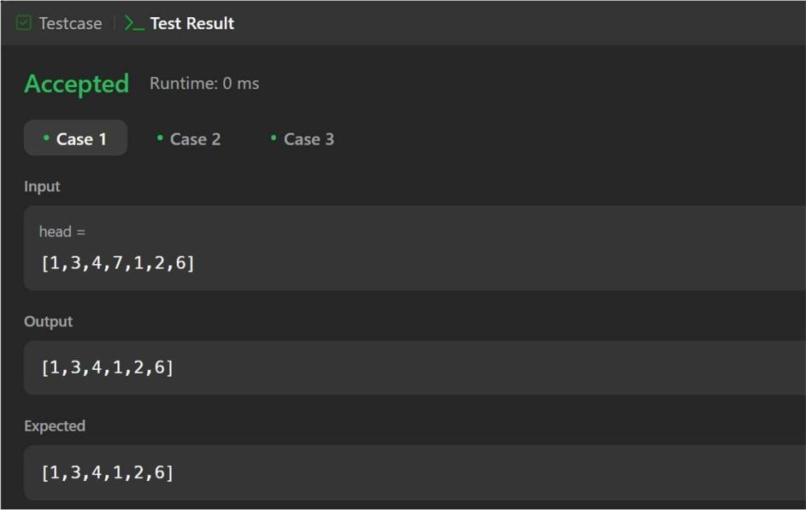

1. **Problem :** Given the head of a sorted linked list, *delete all nodes that have duplicate numbers, leaving only distinct numbers from the original list*. Return *the linked list sorted as well*.

# Algorithm:

1. Create a dummy node pointing to head. This helps handle edge cases where the first node gets deleted.
2. Initialize prev pointer to dummy, which will track the last unique node.
3. Traverse the list while head is not nullptr:
   * If head->val == head->next->val, move head forward until all duplicates are skipped.
   * Update prev->next to head->next to remove duplicates.
   * Otherwise, move prev forward.
4. Return dummy->next, as the modified linked list.

# Code:

class Solution {

public:

ListNode* deleteDuplicates(ListNode* head) { ListNode* dummy = new ListNode(0, head); ListNode* prev = dummy;

while (head != nullptr) {

if (head->next != nullptr && head->val == head->next->val)

{

while (head->next != nullptr && head->val == head->next->val)

{

head = head->next;

}

prev->next = head->next;

} else

{

prev = prev->next;

}

head = head->next;

}

return dummy->next;

}

};

# Output:

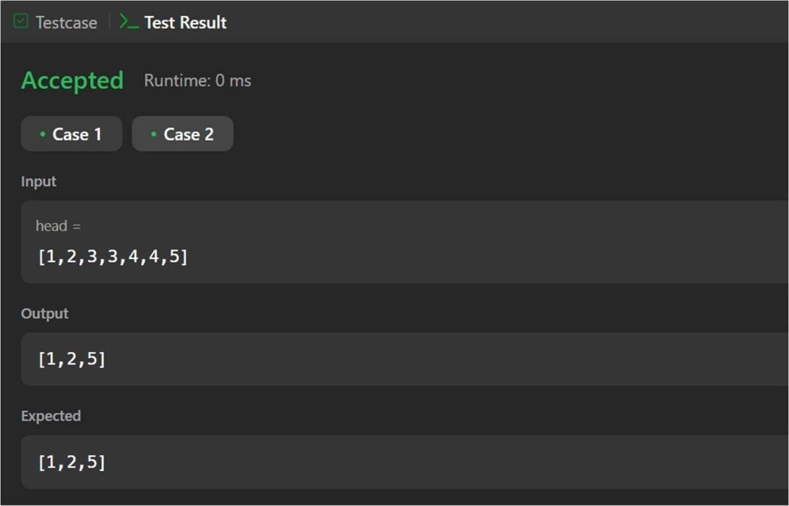

1. **Problem :** Given head, the head of a linked list, determine if the linked list has a cycle in it.

# Algorithm:

## Initialize two pointers:

* + slow moves **one step** at a time.
  + fast moves **two steps** at a time.

1. **Traverse the linked list** while fast and fast->next are not nullptr:
   * Move slow forward by one step.
   * Move fast forward by two steps.
   * If slow == fast, a cycle is detected → **Return true**.
2. If the loop exits (fast reaches nullptr), return **false** (no cycle).

# Code:

class Solution { public:

bool hasCycle(ListNode *head) { ListNode

*slow = head, *fast = head;

while (fast != nullptr && fast->next != nullptr) { slow = slow->next;

fast = fast->next->next;

if (slow == fast) { return true;

}

}

return false;

}

};

# Output:

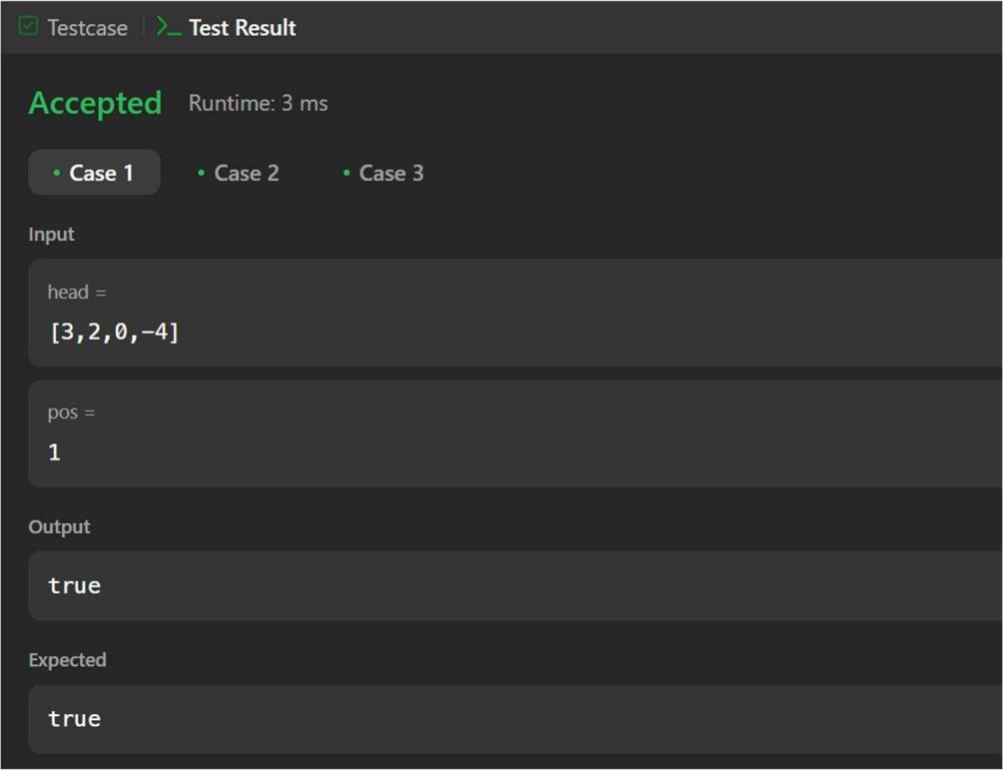

1. **Problem :** Reverse linked list**.** Given the head of a singly linked list and two integers left and right where left <= right, reverse the nodes of the list from position left to position right, and return *the reversed list*.

# Algorithm:

1. Edge case: If the list is empty or left == right, no need to reverse anything, so return the list as is.
2. Create a dummy node and set it to point to head. This simplifies handling the edge case when the sublist starts at the head.
3. Move the prev pointer to the node just before the left-th position.
4. Reverse the sublist:
   * Start from the left-th position, iteratively reverse the nodes between left and right.
   * For each iteration, adjust pointers so that the nodes between left and right are reversed.
5. Return the modified list starting from dummy->next.

# Code:

class Solution { public:

ListNode* reverseBetween(ListNode* head, int left, int right) { if (head == nullptr || left == right) {

return head;

}

ListNode* dummy = new ListNode(0); dummy->next = head;

ListNode* prev = dummy;

for (int i = 1; i < left; ++i) { prev = prev->next;

}

ListNode* curr = prev->next; ListNode* next = nullptr;

for (int i = 0; i < right - left; ++i) { next = curr->next;

curr->next = next->next; next-

>next = prev->next; prev->next

= next;

}

return dummy->next;

}

};

# Output:

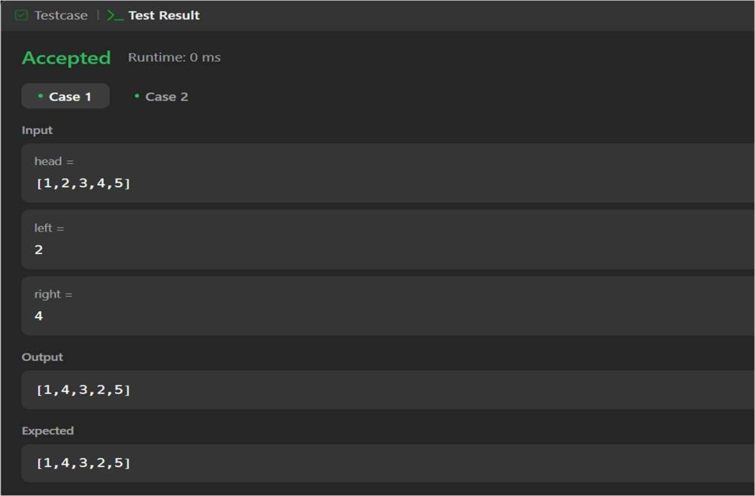

1. **Problem :** Given the head of a linked list, rotate the list to the right by k places.

# Algorithm:

1. Edge case check:
   * If head is nullptr, the list is empty, so return head.
   * If the list has only one node or k == 0, return head as no rotation is needed.
2. Find the length of the list:
   * Traverse the list to calculate its length and find the last node.
3. Form a circular list:
   * Connect the last node's next pointer to the head to form a circular linked list.
4. Calculate the effective k:
   * Since rotating the list by k positions is the same as rotating it by k % length, compute the effective number of rotations.
5. Find the new head:
   * Traverse the list to find the new tail, which is at position length - k - 1, and set the new head to newTail->next.
6. Break the circular list:
   * Set newTail->next = nullptr to disconnect the circular connection and finalize the list rotation.

6. Return the new head.

# Code:

class Solution { public:

ListNode* rotateRight(ListNode* head, int k) {

if (head == nullptr || head->next == nullptr || k == 0) { return head;

}

ListNode* current = head; int length = 1;

while (current->next != nullptr) { current = current->next; length++;

}

current->next = head; k = k % length;

if (k == 0) {

current->next = nullptr; return head;

}

ListNode* newTail = head;

for (int i = 1; i < length - k; i++) {

newTail = newTail->next;

}

ListNode* newHead = newTail->next; newTail->next = nullptr;

return newHead;

}

};

# Output:



1. **Problem:** You are given an array of k linked-lists lists, each linked-list is sorted in ascending order.

# Algorithm:

1. Edge case check:
   * If the input lists is empty, return nullptr.
2. Min-Heap Initialization:
   * Use a min-heap (priority queue) to efficiently get the smallest node.
   * Define a custom comparator to compare nodes based on their values (a->val > b->val).
3. Push heads into the min-heap:
   * Loop through each linked list and push the head node of each list into the min-heap.
4. Merge the lists:
   * Create a dummy node to simplify the merging process.
   * Pop the minimum node from the heap and add it to the merged list.
   * If the popped node has a next node, push the next node from the same list into the heap.
5. Return the merged list:
   * Skip the dummy node and return the merged list starting from dummy->next.

# Code:

class Solution { public:

ListNode* mergeKLists(vector<ListNode*>& lists) { if (lists.empty())

return nullptr;

auto compare = [](ListNode* a, ListNode* b) { return a->val > b->val;

};

priority_queue<ListNode*, vector<ListNode*>, decltype(compare)> minHeap(compare); for (ListNode* list : lists) {

if (list) {

minHeap.push(list);

}

}

ListNode* dummy = new ListNode(0); ListNode* current = dummy;

while (!minHeap.empty()) { ListNode* node = minHeap.top(); minHeap.pop();

current->next = node; current = current->next;

if (node->next) { minHeap.push(node->next);

}

}

return dummy->next;

}

};

**Output:**

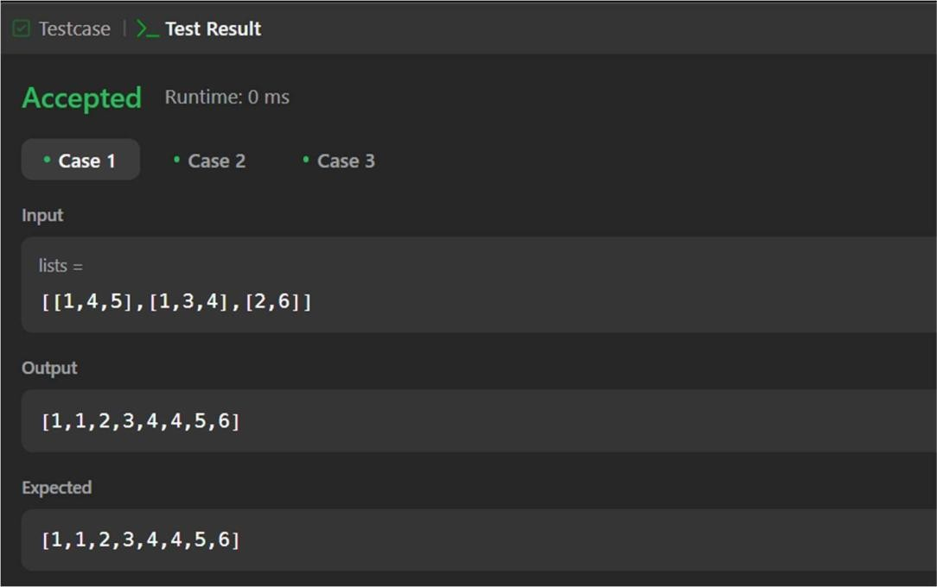

**4.Learning Outcomes:**

* Merging multiple sorted linked lists into one sorted linked list and Removing duplicate elements to retain only distinct values.
* Utilizing Data Structures Efficiently by Using priority queues (min-heaps) for efficient merging of k sorted lists.
* Implementing Sorting and Merging Algorithms like Heap based sorting.
* Handling edge cases such as empty lists or single-node lists.